**Arizona PTA encourages you to take advantage of this National program and work with your community to become the best local unit you can.**

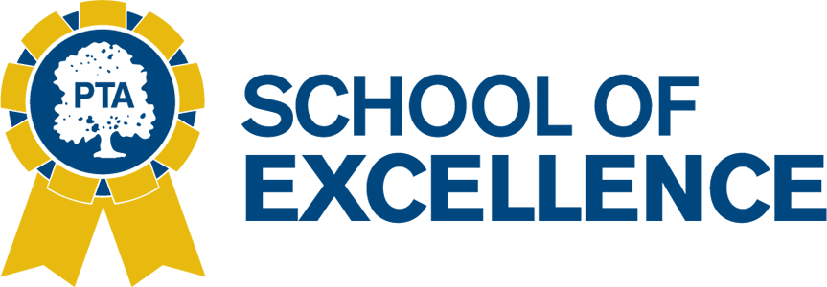

**What is it??**

The National PTA [School of Excellence](http://www.pta.org/excellence) recognition program opens the lines of communication and critical thinking within school communities to make data-driven decisions that yield positive, long-term results.

By enrolling in this year-long program, your PTA and school administrators are making a joint commitment to identify and implement an action plan for school improvement based off of direct feedback from your school community. Throughout the school year, you will work with a committed team of PTA leaders you choose to strengthen the family-school partnerships in your community. And National PTA will be there every step of the way to offer support and resources.

**What Is the time line??**

**Step 1:** Enroll and Gain Support (Now –Oct. 1)

**Step 2:** Deploy Baseline Survey (Sep. –Nov.)

**Step 3:** Set a Shared Objective (Sep. –Nov.)

**Step 4:** Complete Initial Application (Submit by Nov. 1)

**Step 5:** Follow Roadmap to Excellence (Throughout School Year)

**Step 6:** Deploy Final Survey (March –June)

**Step 7:** Complete Final Application (Submit by June 1)

**Step 8:** Celebrate Your Excellence (Aug.)

**Where do I enroll?** [www.pta.org/Excellence](http://www.pta.org/Excellence)

**What resources do I have?** On the National PTA website you have how to videos, sample enrollment forms, shareable promotion materials, examples from other school of excellence winners, and FAQs.

**Questions?** Contact [Excellence@PTA.org](mailto:excellence@pta.org)